**SECTION A (60 Marks)**

Answer only **three** questions from this section.

1. State Le Chaterlier’s Principle. (02 marks)
2. Hydrogen iodide decomposes according to the following equation.



1. State the condition for the reaction. (0½ mark)
2. Describe how the equilibrium constant, for the reaction can be determined by titrimetric method. (08 marks)
3. Explain what would happen to the equilibrium position if:
4. Catalyst is added. (02 marks)
5. Some little potassium solution was added to the mixture. (02½ marks)
6. 102.4 g of hydrogen iodide was heated to equilibrium in 5000 cm3 vessel. If 44.8 g of the hydrogen iodide remained at equilibrium, calculate the value of equilibrium constant, 𝐾𝑐. (05 marks)
7. Discuss the reactions of
8. Methyl benzene with chlorine.
9. Ethanol with sulphuric acid.
10. Chloroethane with potassium hydroxide.

You answer should include:

1. Equations for each reactions.
2. Acceptable mechanisms for each reactions. (20 marks)

1. Explain each of the following statements.
2. Glucose, 𝐶6𝐻12𝑂6 is much more soluble in water than in benzene.

(03 marks)

1. Silicon dioxide is a covalent compound but has a very high melting point. (03 marks)
2. An aqueous solution of 0.020 M sucrose has the same freezing point depression as 0.010 M potassium chloride. (04 marks)
3. Calcium oxalate is insoluble in water but readily dissolves in dilute nitric acid. (05 marks)
4. Silicon tetrachloride fumes in most air but carbon tetrachloride does not. (05 marks)
5. The table below shows the melting points of some of the elements in Period 3 of the Periodic Table.

|  |  |  |  |  |  |  |  |  |
| --- | --- | --- | --- | --- | --- | --- | --- | --- |
| Elements | 11Na | 12Mg | 13Al | 14Si | 15P | 16S | 17Cl | 18Ar |
| Melting point  (ᵒC) | 98 | 650 | 660 | 1,423 | 44 | 120 | -101 | -189 |

1. State what meant by the term **melting point**. (01 mark)
2. Explain:
3. The trend in the melting point of the elements from sodium to aluminium. (02½ marks)
4. Why the melting of silicon is very high. (01½ marks)
5. Why the melting point of sulphur is much higher than that of chlorine. (02 marks)
6. (i) Write equation to show how anhydrous aluminium chloride can be prepared. (01½ marks)
7. Aluminium chloride was dissolved in water and the solution tested with litmus paper. State what was observed and explain your answer. (04 marks)
8. Write equation and state the conditions under which sodium hydroxide can react with:
9. Aluminium. (02½ marks)
10. Chlorine. (05 marks)

**SECTION B (40 Marks)**

Answer only **two** questions from this section.

1. The table below shows the boiling points and mole fraction of methanol (b.pt = 65oC) in mixtures of methanol and cyclohexane (b.pt = 81oC) in the liquid and vapour phase.

|  |  |  |
| --- | --- | --- |
| Boiling point of the mixture (ᵒC) | Mole fraction of methanol in the liquid mixture | Mole fraction of methanol in the vapour mixture |
| 70 | 0.12 | 0.27 |
| 60 | 0.31 | 0.47 |
| 55 | 0.50 | 0.56 |
| 54 | 0.56 | 0.66 |
| 57 | 0.82 | 0.69 |
| 61 | 0.94 | 0.83 |

1. Plot a boiling point-composition diagram and label it fully. (04 marks)
2. Explain the shape of the diagram. (04 marks)
3. Explain using the diagram what will happen when a mixture containing 0.2 mole fraction of cyclohexane is fractionally distilled. (03 marks)
4. Nitric acid and water forms non-ideal a liquid mixture that deviates negatively from Raoult’s law. The azeotropic mixture boils at 120oC, contains 68% of nitric acid and has a density of 1.42 g dm-3.
5. State **Raoult’s law**. (02 marks)
6. Calculate the molar concentration of nitric acid and hence the volume of the acid required to prepare 250cm3 of 0.05M solution. (H=1; N=14; O=16 ) (04 marks)
7. Write equations to show how each of the following compounds can be synthesized. In each case, indicate the reagents and suitable reaction conditions.
8. Propanone from propan−1−ol. (05 marks)
9. Cyclohexane from methylbenzene. (04 marks)
10. Complete the following equations and in each case outline a mechanism for the reaction.



1. Describe how sulphuric acid can be prepared on industrial scale starting from zinc sulphide.

(*Your answer should include equations for the relevant reactions and no diagram(s) required*) (8 marks)

1. Discuss the reactions of sulphuric acid can react with:
2. Copper. (02½ marks)
3. Carbon. (02½ marks)
4. Copper (II) sulphate crystals. (02½ marks)
5. Describe briefly how crystals of zinc sulphate, 𝑍𝑛𝑆𝑂4.7𝐻2𝑂 can be prepared from zinc hydroxide. (03 marks)
6. Write equation to show the reaction which takes place when zinc sulphate crystals are strongly. (01½ marks)
7. Explain each of the following observations and where applicable illustrate your answer with equation(s).
8. Oxygen and sulphur are both elements in the group VI of the Periodic Table. Oxygen is a gas but sulphur is a solid at room temperature. (05 marks)
9. The first ionization energy of aluminium is less than that of magnesium. (03 marks)
10. When concentrated hydrochloric acid is added to a solution of cobalt (II) chloride the colour of the solution changes from pink to blue. When water is added to the resulting solution mixture it changes back to pink. (05 marks)
11. Methanoic acid reacts with a mixture ammonia and silver nitrate solutions to form silver mirror whereas ethanoic acid does not. (04 marks)

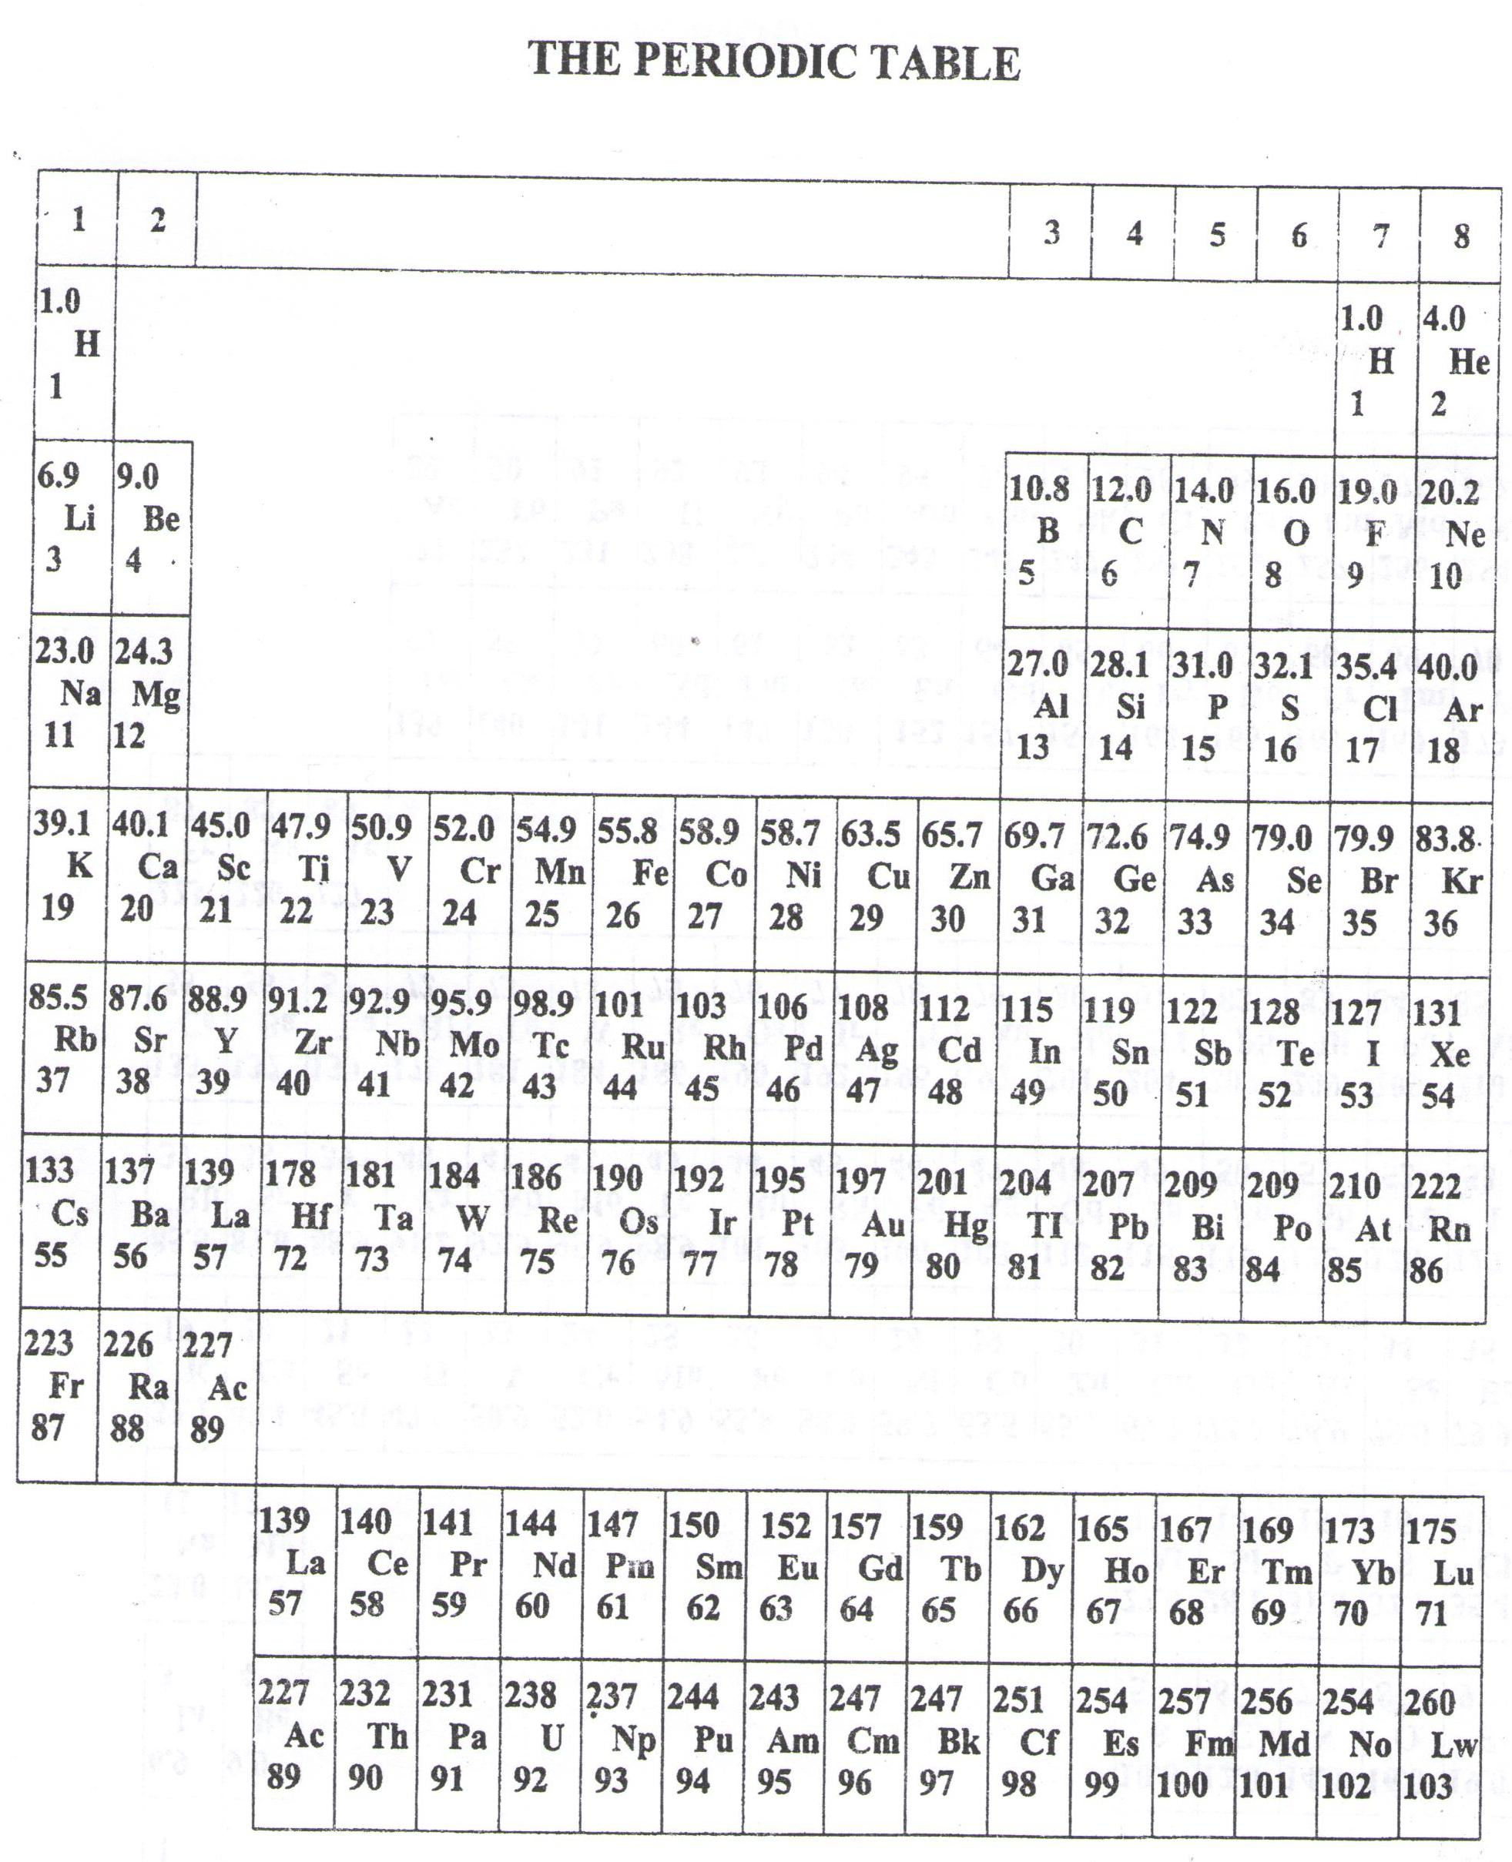

* ===END===

WELCOME TO SENIOR SIX, YEAR 2023

This is the last page of the printed paper, Page 06